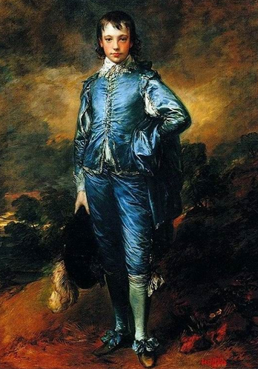庚斯博罗 1770

《蓝衣少年》描绘了一个衣饰华丽的贵族少年形象。 其实，这一模特儿原型并非贵族，而是画家找来一个富有的工场主的儿子，庚斯博罗让他穿上蓝色华服，扮成王子模样而画成的。庚斯博罗用奔放的笔触，轻灵流畅地把少年那种倜傥风度表达得淋漓尽致，充分发挥了宝石蓝的光色作用。这新颖别致的蓝色调不但没有任何不适之感，反而使人感到出奇制胜；这活泼、跳跃的蓝色绸缎，这变幻莫测的衣纹、高光；这不落俗套的蓝色调与含蓄、变换丰富的黄灰、蓝灰、绿灰、红灰的背景形成了奇妙的和谐对比 。这里最成功地方是，画家用准确的色块再现了少年身上的蓝缎子织物的质感和薄软感。整幅画的风格清新流利，色彩富有节奏感，抑扬有度，从而使此画作成为十八世纪最杰出的肖像画之一，在世界美术史上占了重要的一页。 正如当时一位评论家所形容的，他把肖像绘成与歌剧一般富有韵致, 这是一个“经过人工处理的真实”。

**1. Before Listening**

|  |  |  |  |
| --- | --- | --- | --- |
| Recede | 后退 | otherwise | 否则 |
| Feature large | v. 有着很大的 | ultramarine | 群青 |
| shade of blue | 蓝色阴影 | sparingly | 谨慎的 |
| Lapis Lazuli | 青金石 | Azurite | 蓝铜矿 |
| smalt | 绘画用的深蓝色颜料 | Impermanent | 短暂的 |
| the wealthy | 有钱人 | the formula | 那个公式 |
| ground | Grind | finely | 细细的 |
| dough | 面团 | time-consuming | 耗时间的 |
| contributed to | 归功于 | sponsor | Subsidize 赞助者 |
| commonplace | 司空见惯的Adj. plain | synthetic | 合成 |
| substitute | replacement |  |  |

**2. While Listening**

**2.1Take Notes on your notebook**

**2.2 Questions**

**1. What is the lecture mainly about?**

A The economic factors that made lapis lazuli expensive

B The types of paintings in which the color blue is popular

C Early processes for making blue pigments from stones

D Difficulties using the color blue in early paintings

**2. What was Gainsborough's goal when he painted The Blue Boy?**

A To find an acceptable alternative to ultramarine pigment

B To demonstrate that blue should be used ~~only~~ in certain paintings

C To contradict a common belief about the use of blue in a painting

D To protest the high costs of painting with most blue pigments

**3. What does the professor imply about smalt as a substitute for lapis lazuli?**

A It eventually became as expensive as lapis lazuli.

B It was used frequently throughout the nineteenth century.

C It was not of an acceptable quality for many artists.

D It was seen as a better substitute for lapis lazuli than azurite was.

**4. What two points does the professor make about the process of turning lapis lazuli into ultramarine? (Click on 2 answers.)**

A It took a lot of time.

B It required expensive tools.

C It did not produce much pigment.

D It was perfected by the French.

**5. Why does the professor mention the French government?**

A To indicate who sponsored the digging of additional lapis lazuli mines

B To emphasize the importance of developing an affordable blue pigment

C To point out that artists were not permitted to use certain stones to make pigments

D To question the government’s use of public funds to support the arts

**6. What does the professor imply when he says this:**

A He is not convinced the Egyptians made the first synthetic pigment

B He is impressed by the Egyptians’ accomplishment.

C The process the Egyptians used is now widely known.

D The Egyptian pigment was of lower quality than today's pigments.

**2.3 Detailed Question**

1) Why does the professor say the painting “Blue Boy” might have been an experiment?

It is believed that blue can not be an important color because it tend to recede in the background

2) What were the two challenges to blue? Can’t be an important color in painting__________________; expensive in the past______________

3) What are the two types of stone that make the two shades of blue (pronunciation)

Lapis Lazuil _______________; Azurite______________

4) What is the cheaper substitute to the above two precious stones? Smalt_________

5) How does the professor explain the preciousness of ultramarine pigment?

A. Make a contrast

B. Make a comparison

C. State the value directly

D. Make a metaphor

6) Why does the professor mention the Impressionists?

Give an example after the innovation of blue elements.

**2.4 Dictation**

Listen to part of the lecture in an art history Class.

Okay. So, When We Were discussing GainSborough's painting, the Blue Boy, Which he painted in 1770, I mentioned the story that the painting might have been an experiment__________________________.

The result of a challenge_______________.

lt was believed that blue ________________________________ in a painting because...Well...it tends to recede into the background_____________________.

Not good for your main subject, right?

So to show ______otherwise________, Gainsborough created the Blue Boy, with the boy featured large in his famous______blue clothes_________...and...well...l guess__________he proved his point__________.

**But** there was another challenge to blue. It was very very ______expensive______ back then.

Now of course, because of modern chemistry, any color is available in tubes at any art supply store. **But** in the 18th century and before, it wasn't so easy.

And blue...well...the color ______ultramarine______, the most _____desired____shade of blue, was made from the precious stone, Lapis Lazuli, which had to be imported all the way from Afghanistan.

And the ___________second-most favored____________shade of blue, after ultramarine made from Lapis Lazuli, was a shade a blue that came from another precious stone, Azurite. But Azurite was...well...__________harder to do work with___________. There's evidence that artists would try to get around these difficulties. For example, ______use pigment________from lapis lazuli or azurite very ______sparingly________, and also use something______cheaper_______, like smalt, which was made of ________ground glass______. Thing is, smalt became ___________discolored_____________. So many artists probably ___________just avoided blues____________altogether rather than use something ____________cheap and impermanent___________________.

**So,** blue, and especially ultramarine pigment, was___________a luxury___________, worth even more than ___­­­­gold_________ at times. And you even have the wealthy ordering paintings with ultramarine to show others that they could _________afford something____________ made from this precious pigment, much in the same way they would_____order gold leaf________.

Actually, the ancient Egyptians________did manage__________ to make an artificial blue, ________the first synthetic pigment_________in fact, if you can believe that. They passed the formula on to the Greeks and Romans, but then it was lost. Anyway, **not only** was lapis lazuli hard to get, it was **also** _________hard to process_________. The recipe was difficult.

The stone had to be __________ground finely________, not easy to do with a rock, then mixed with melted wax, resins and oils, wrapped in a cloth and knitted like bread dough. The fine particles of ultramarine were then separated from the rest. The process was ___________time-consuming____________, which also ________________contributed to the high cost of______________ producing ultramarine, **and** it didn't even____________yield very much usable pigment______________. **As a result**, the _____French_____ government_______sponsored a competition_______ in 1824 to find a ______cheaper_______ way to make ultramarine pigment. And soon after a process was demonstrated where a combination of _______coal, sulfur_____ and other _________cheap, commonplace substance___________were heated, creating a suitable _______________ for lapis lazuli.

**So** there's no doubt that **____nineteenth____-century artists**, after good ________synthetic_________were available, used more ultramarine. Think of __________impressionists_________, **for example.** They had a lot more choices or at least,______less expensive chioces_______ choices, than painters not that long before them.

**2.5 general structure of the lecture**

**Topic: Difficulties in using Blue color in early paintings**

**Introduction:** with an example ___________of Blue boy______________.

It served as an ____experiment_____ to the traditional belief that___________blue couldn’t be an important color in a painting__________

**Explanation of the difficulties** :

The most desired shade of blue _____________made from lapis lazuil_______________

The second desired shade of blue _________made from azurite__________________

Difficulties in using blue:____________expensive__________ ; ________hard to produce/ time consuming_______

**Reaction to the difficulties:** find substitute 1) _________subsidies____________

2) __________avoid using blue combinations___________

**Solution of the problem:** __________________invent a new substitute for blue__________________________

**3. After Listening**

**Make a summary of the lecture**

**The lecture talks about the difficulties of using blue pigments in the past. The first difficulty is its price. These pigments were made of ores called lapis lazuli and azurite. Because of their price, artists avoid to use blue and its combinations. The second difficulty is its production length and process. These ores need to be grinded carefully and wrapped into a cloth and so on. These two difficulties led to a competition held by the France government, that eventually led to a new blue pigment.**

**Correction**

|  |  |  |
| --- | --- | --- |
| **SN** | **Types of Questions** | **Analysis** |
| **1** |  |  |
| **2** |  |  |

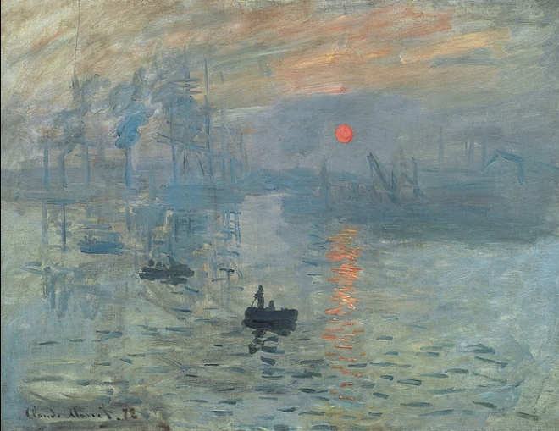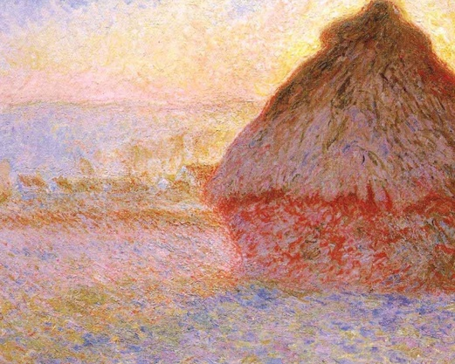

印象主义Impressionnism（1874-1886）：不依据可靠的知识，以瞬间的印象做画。

代表画家： [莫奈](http://baike.baidu.com/subview/17359/10147333.htm)、[雷诺阿](http://baike.baidu.com/view/17656.htm)、[毕沙罗](http://baike.baidu.com/view/20959.htm)、[西斯莱](http://baike.baidu.com/view/310092.htm)、[德加](http://baike.baidu.com/view/192973.htm)、[塞尚](http://baike.baidu.com/view/17062.htm)和莫里索

**Impressionism** is a 19th-century [art movement](https://en.wikipedia.org/wiki/Art_movement) characterized by relatively small, thin, yet visible brush strokes, open [composition](https://en.wikipedia.org/wiki/Composition_(visual_arts)), emphasis on accurate depiction of light in its changing qualities (often accentuating the effects of the passage of time), ordinary subject matter, inclusion of *movement* as a crucial element of human perception and experience, and unusual visual angles. Impressionism originated with a group of Paris-based artists whose independent [exhibitions](https://en.wikipedia.org/wiki/Art_exhibition) brought them to prominence during the 1870s and 1880s.